Notes on How to Use TransformApplier
Ed Wiley, AAVSO WEY

Introduction
TransformApplier is a utility written by George Silvis that allows batch transformation of variable star data into the standard system. As is usually when I learn a new software program, I took detailed note on procedures as I learned the program. This document is the result. I have always found that having a test file assures that first users of new software benefit from duplicating “known” results and have made available a set of data and the output for comparison as a separate zip file that contains various txt files. There are parts of the program I have not investigated, as noted. I also provide some notes on what I consider a valuable subprogram, “TestTC.” However, George is still working on this part of the program suite, so my notes on TestTC should be viewed as preliminary and written in the spirit of “if its there someone will try to use it.”

1. Download and open TransformApplier.
TransformApplier is one of three software packages offered at https://www.aavso.org/transform. The link is in the Data Analysis set of pages at https://www.aavso.org. The download consists of an executable file TransfornApplier.exe.
2. Organization.
There is a single high-level pull-down “File” menu including commands that can input an AAVSO formatted file, and various save functions that allow downloading of reports, etc. as text files.
Open un-transformed obs file. Unless you are doing a single filter transformation you would load two (2) files, one for each filter. See tutorial.
Save un-transformed obs to file. Use this to save the combined file, for example, if you input a series of B-filter and V-filter data you would get out a single text file that combines both.
Save transformed obs to file. This save the output in the window Application – The transformed records are here… into a txt file tagged TA and suitable for downloading in WebObs.
Save report to file. Save the information on the Report page. Note that this is NOT a report suitable for WebObs, see below.
3. Windows.
There are five windows in TransformApplier, each accessed by tabs of the same name and each containing either text boxes or forms.
Application. Upper text box for entering data. Lower text box presents the results of the analysis in a format that can be read by WebObs when saved.
Report. Presents, in the text box, the results of the transformation in such terms as the difference between transformed and untransformed results. This is not a WebObs-compliant report, as detailed below.
Coefficients. A form window that allows you to enter the transformation coefficients. Note that this uses AAVSO transform notation. Also note the error terms are used. See Help for information on error terms. You should generate a *.ini file to hold each set of coefficients (save as button) and can call up any set with the change button.
Extinction. A form window allowing input of extinction terms. Consult Help for information and the need to enter or disregard extinction terms.
Help. Read this too!
4. Operation – Application Window
Data input. You may either open from File or paste your untransformed data into the upper text box. Note that the test data have the check and comp star names in the example data (125 and 120 in this case) are changed to their AUID numbers. This is usually not needed as the program will correctly read these stars based on the AAVSO chart number.
Methodology. The Help menu outlined three different methodologies depending on alternate transformation equations (AAVSO, Alternate, Classic). Be informed on which you use. The tutorial uses AAVSO.
DSLR is for WebObs-compatible DSLR transformation reports. Data submitted from a DSLR will have filters TB, TG and TR. Checking this box tells TA to use B, V and R reference data.
Test TC can be used to test how well your transformation coefficients perform given a set of data from a standard star or stars, a valuable check on TC coefficients. The current version is a beta version, use with caution.
Aggregate will aggregate observations according to the criteria outlined in the Help file. This might be used for slow-changing M-class variables but not for eclipsing binaries or other variables that vary over short time periods. The tutorial has a set of data on an eclipsing binary, thus Aggregate is not used.
Standard Field is checked if you are using a chart of a standard field (e.g. M67). I have not used this feature.
Process begins the analysis, with intermediate output shown in the lower text box.
5. Save the file as a WebObs compatible file
Use “File Save transformed obs to file” to download a report as a WebObs-compatible txt file. You are now ready to report your transformed data to AAVSO. A copy of the result of the example data is in the folder, see tutorial below. Please do not report these data to AAVSO.

6. The Report Window
The Report window’s text box is NOT the text box that will generate a WebObs report when the txt file is saved; you have already done this in (5.) above. Rather, it provides information on the transformations, observation by observation. For example, below:

Star Date Filter Grp Vraw Vinst Vex TranMag diff VERR VERRt
"V0347 Dra 2458285.69267 B 0101 13.501 -7.176 -7.176 13.553 0.05165 0.006 0.007

Vraw: measured standardized magnitude from the input record.
Vinst: the raw instrumental magnitude, backing out the standardization
Vex: Vinst with extinction applied. No change if not applying extinction
TranMag: The magnitude after transformation
Diff: difference between untransformed and transformed magnitude
Verr: magnitude error as reported from the input record
Verrt: magnitude error for the transformed magnitude
6. Using the Test TC utility
George Silvis considers the “Test TC” utility to be a beta version, so its use must be considered with caution and the expectation that further improvements and additional information on proper use will be made as he has time. I used the current version and found it to have considerable potential in its primary function; checking the quality of transformation coefficients. It takes the check star measures and instrumental magnitude, transforms the data, and then compares the transformed value against itself as found in the AAVSO photometry table. The check star is considered a secondary standard; the difference should be an indication of the success of the transformation coefficients to successfully transform the measured value to the standard system. Since the standard magnitude of the check star is associated with an uncertainty, one might expect that the differences (“diff” column in the Transform Coefficient Test Report) to fall within some range given the uncertainty.
The following is not a definitive method for determining the validity of your transformation series, it is my attempt to understand that output. After running TestTC, I copied the Report page to a text file and saved it as “TestTC_Report” (included in the zip file). I noted from the Photometry Table that the check star 125 (AIUD 000-BMR-476) is an APASS star with an uncertainty of +/- 0.042 in Johnson B and +/- 0.020 in Johnson V.
If you examine all the range of difference (diff) data for both Johnson B and Johnson V, you will note that all but one observation in each filter fall within two standard deviations of the uncertainty. Further, the two that deviate more than 2Sd are the last of each pair, indicating a common cause for the deviation. If you average all the differences except the last for each filter you find that the average for B is slightly over the published uncertainty while the average for V is slightly under the average uncertainty. Both observations indicate to me that the transformation coefficients for these filters are useful.

Acknowledgement: I thank George Silvis for patiently answering my many questions about TransformApplier.

Tutorial example
A series of B and V observations were made of V0347 Dra, an eclipsing binary after an eclipse as part of a period study by WEY and colleagues. The two observation files and a file of results are included in the zip file.
1. Unzip the file and example the data. Note that I have substituted the AUID values for comp star 120 and check star 125. Do not do this with your data unless necessary.
2. Open TransformApplier.
3. Open the Coefficients window and copy the information below.

3. Open the Application Window. Using File, open the two files of data, one after the other. The data will appear in the upper text box. Scroll down to ensure that both data files are in the box.
4. Select AAVSO Methodology. Make sure that other options are not selected (DSLR, etc.) and then select Process.
5. The results will appear in the lower text box. Save these results (File Save transformed obs to file. This file will be named “AAVSOReport_V0347-Dra_V_20180624_TA” with the “V” after the second file of data loaded. A copy is in the example folder. A screen shot of the Application window with part of these data is shown below.

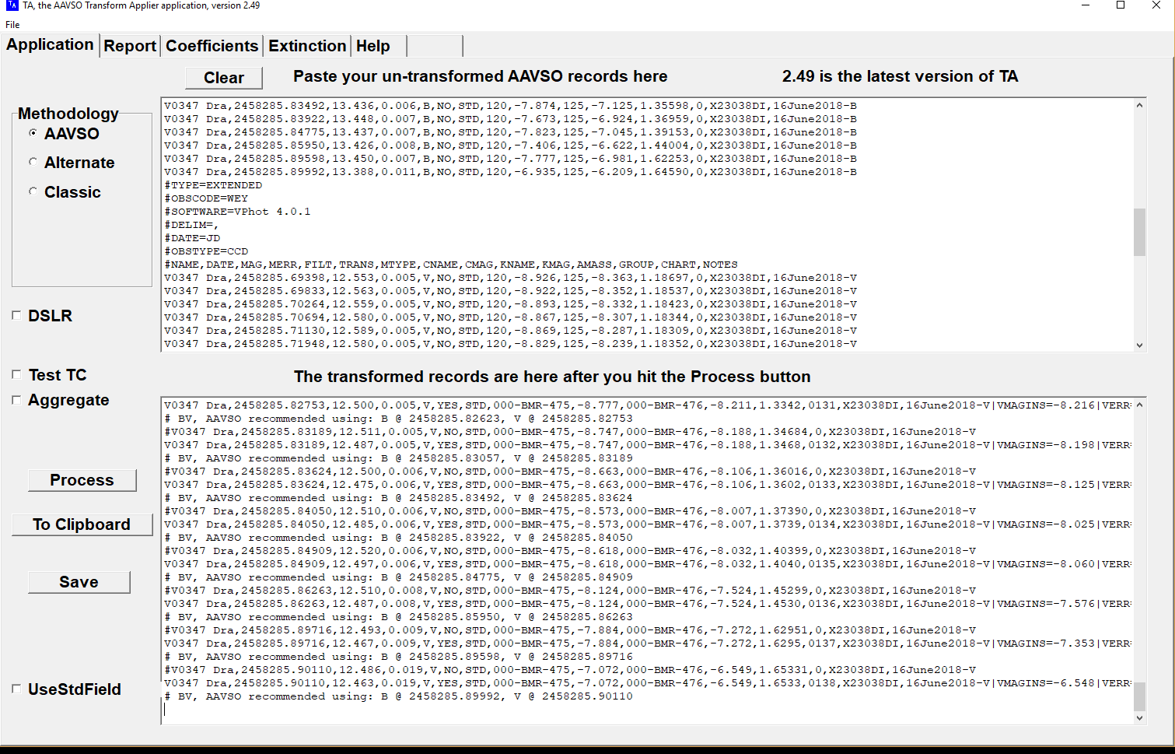

6. Below is a screen shot of the Report text box, again, note that this is not the window for reporting data to WebObs, it is a report of the transformation process.

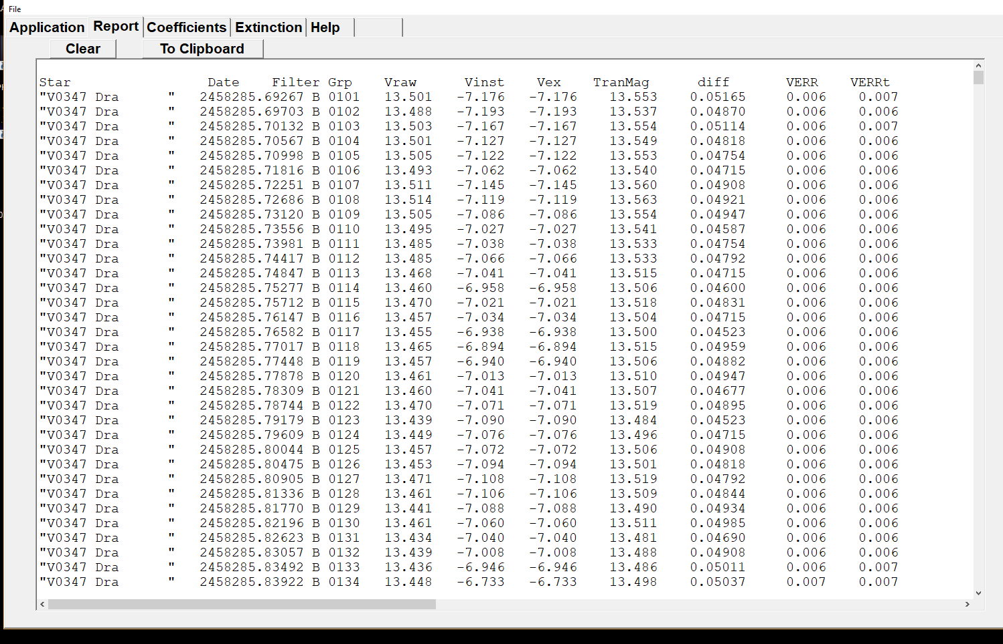

Checking the quality of your transforms
1. To reduce clutter clear the Report screen.
2. Simple run the data again with the “Test TC” button activated.
3. Scroll down to the bottom of the Report page to view the results.
4. As TestTC is in beta version, interpretation of results should be cautious and preliminary.

