Fig. 1. Screen shot of a time series of the variable NSVS3092802. This is one of three times series processed today (28 Aug 2019). The other two analyses were flawless. Note the scattering of results in the middle of the run.

Fig. 2. Variable, check and comp as plotted in the Sequence file. This is the same for all beginning and ending images in the time series. All apertures places correctly.

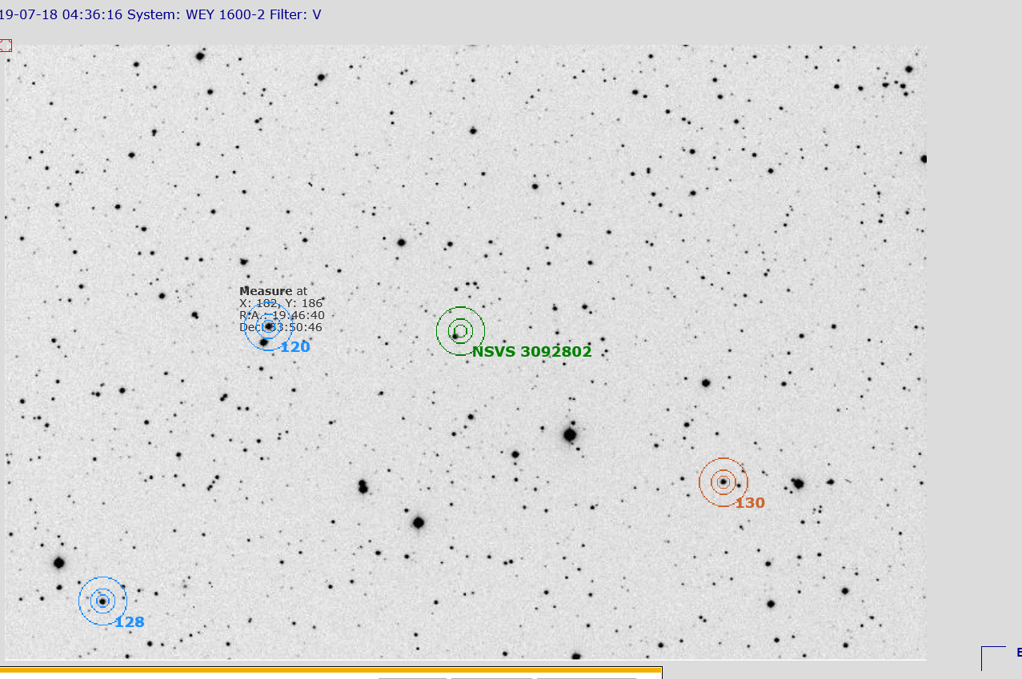
Figure 2. A sample image from the middle of the time series. Note that the comps and check apertures plot fine, but the variable’s aperture is offset, above the variable.

Fig. 3. Another samples image from the middle of the run. Note that the variable’s aperture is set below, 180 degrees opposite of Fig. 2. Again, comp and check apertures plot correctly.

