PERSONAL EXPERIENCE WITH THE ZWO ASI1600MM COOLED MONOCHROMATIC CMOS CAMERA FOR VARIABLE STAR PHOTOMETRY
Roy Axelsen (ARX)
For the observations and measurements made and described in this document, the following table of equipment, software and procedures applies.
Date of purchase of camera | Just before mid 2019
Accessories | ZWO five position mini filter wheel  Photometry filters (interference filters): Johnson B and Johnson V  I chose “unmounted” 31mm filters because the clearance inside the filter wheel housing is limited (but see the ZWO web site for comment on this issue)
Telescopes | 80mm refractor, ED doublet, focal length 600mm (f/7.5), and  120mm refractor, ED doublet, focal length 900mm (f/7.5)
Mount | German equatorial, autoguided using a guide ‘scope, guide camera and PHD2 Guiding software
Camera control & image capture | APT – Astro Photography Tool¹
Image processing and aperture photometry | AIJ - AstroimageJ
Preprocessing | Darks (same duration as science images²) and flats  Bias frames have not always been used. ZWO claims they are not necessary
Planned targets | Typically, high-amplitude delta Scuti stars³
¹ The camera control dialog can be called from APT or other image capture software. Alternatively, ASICAP, the more basic camera control software provided by ZWO can be used.
² Science images are defocussed. The degree of defocus will be illustrated in what follows with images of target fields and line profiles of star images.
³ Delta Scuti stars are short period pulsators with periods of up to a few hours. Therefore, time series photometry is preferred for studying them. In my hands, this means scheduling image capture throughout the night, executing a meridian flip when necessary, and exposing each image for up to 180 seconds. My interest is therefore in achieving the best precision for single exposures. Although it is possible to calculate rolling averages of magnitudes prior to plotting light curves, and although that smooths the light curves, I prefer not to do this if possible.
Image type
The camera control dialog allows either “RAW8” and “RAW16” images to be selected (Figure 1). If ASICAP (the manufacturer’s camera control and image capture software) is used for image capture, the RAW8 setting results in images saved in the .png format. RAW16 images are saved in the .fit format. I only ever use the RAW16 setting.
Interestingly, if RAW8 is selected when the camera control dialog is called from Astro Photography Tool, and an image taken, the file is save with a .fit extension, but AstroimageJ will not analyse it
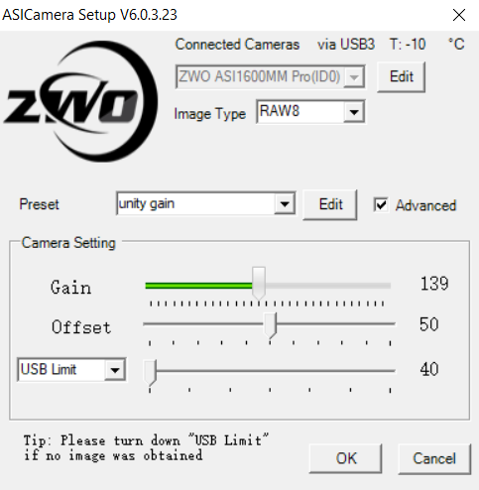 | 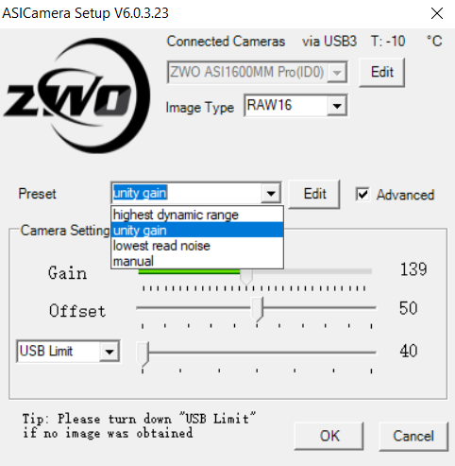
Figure 1. Camera control dialog, called from Astro Photography Tool capture software.
Gain settings
This ZWO ASI1600MM camera allows gain settings from about 0.2 e/ADU to 5 e/ADU. The camera control dialog (in which you set the gain) can be called from your own image capture software. The gain is actually set in units of 0.1 dB, 300 dB units corresponding to 0.2 e/ADU (lowest read noise), 139 dB units corresponding to unity gain (1 e/ADU) and 0 dB units corresponding to 5 e/ADU (highest dynamic range)(Figure 2).
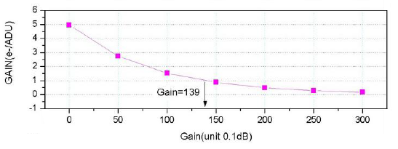
Figure 2. Gain settings for the camera. Part of an illustration from the ZWO ASI manual
The camera control dialog allows “click stop” gain settings of 0 dB units, 139 dB units or 300 dB units. When using one of these click stops, the image type defaults to RAW16. A fourth “click stop” is “manual”, which means you use the mouse to drag a slider to any gain setting you wish from 0 to 300 dB units. If you have set the image type to RAW8, then use the slider to manually set the gain, the RAW8 image type remains in place.
I find no benefit in using gain settings greater than 139 dB units. That is, I do not use amplification of the signal (and therefore the noise). For the brightest targets, it is valuable and may even be necessary, to use gain settings between 139 and 0 dB units (that is, between 1 and 5 e/ADU).
Just a few words about amplification (gain settings between 139 and 300 dB units). In this range, the read noise is less than it is at gain settings less than 139, and much has been made of this property of the camera for stacking multiple short exposures. However, as I understand it (and I’m only paraphrasing here what I think I understand from reading the views of others), the advantage which can be bestowed by low read noise is only present when the read noise is the dominant form of noise, and this only occurs in low illumination environments, with low signal sky backgrounds. My environment is not like that – I image in a suburb about 9 km from a city, with high sky background signal, and shot noise (due to the random nature of the rate of arrival of photons at the sensor) dominating over read noise. Therefore, I cannot take advantage of the low read noise range of the gain settings of this camera.
DESCRIPTION OF THE RESULTS OF USING THE CAMERA
Linearity
Testing was done with flat frames at various exposure times, up to saturation (full well) of the sensor. Whether binned 1x1 or 2x2, the full well is 65,504 counts per pixel at unity gain (see note at the end of this section on these high counts) and the response has a good linear fit (as seen with linear regression and plotting residuals)(Figures 3 and 4) until quite close to that, around 64,000 counts (these values are seen with AstroimageJ). The results in Figures 3 and 4 were from images binned 2x2.
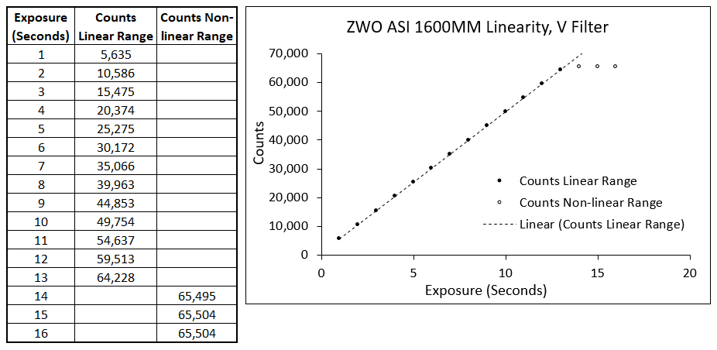
Figure 3. Linearity test, unity gain (139 dB units, 1e/ADU).
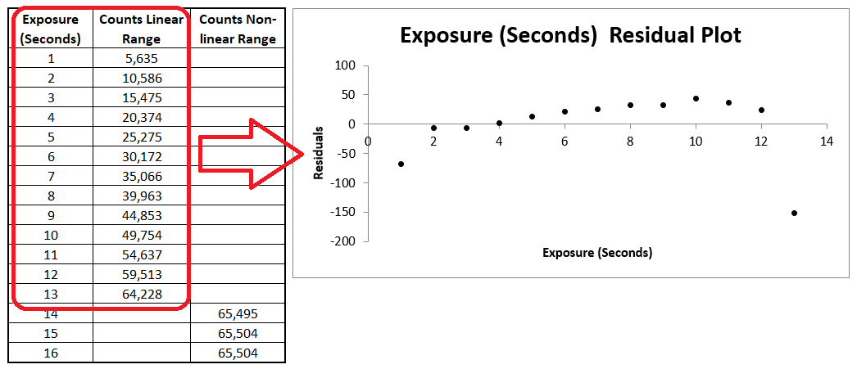
Figure 4. Residuals plot from regression analysis of the linearity date. The table contains the original data, the same as in Figure 3. The regression analysis with the residuals plot was undertaken only on the data in the linear range (enclosed in red in the table).
A word of caution. The above linearity test was at unity gain (139 dB units, 1e/ADU). In a further linearity test with gain set at 0 dB units (5e/ADU), the sensor saturated at counts below 60,000 which is several thousands counts per pixel lower than that seen at unity gain. Figure 5 shows the plot, from images binned 1x1. Note that the counts in the non-linear range do not actually plateau (as was the case at unity gain), but very slowly increase with increasing exposure time. Residuals from the regression analysis (not shown here) did not show the linearity to be as good as at unity gain, but the test needs to be repeated to check this. Nevertheless, the overall result is clear with respect to the counts near which saturation occurs, so be careful of the saturation point if using this gain setting.
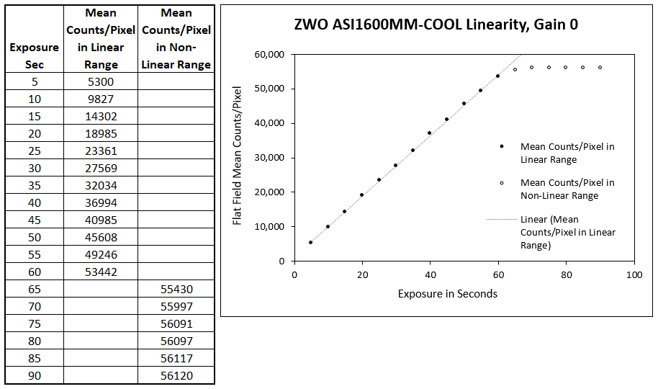
Figure 5. Linearity at a gain setting of 0 dB units (5e/ADU). Saturation occurs several thousand counts less than that seen at unity gain (139 dB units, 1e/ADU).
It is clear from these results (saturation occurring at 65,504 counts at unity gain, in unbinned images and images binned 2x2) that binning 2x2 (and higher, presumably) is done by software, which simply averages the ADUs over each 4 binned pixels in an image binned 2x2. The results are: a .fit file of 8MB (instead of 32MB in an unbinned image); a cleaner background; fainter stars more readily visible against the background; and a smoother line profile of a star image. I now use 2x2 binning routinely because of these cosmetic and memory-saving benefits. I’ve yet to determine if binning improves photometric precision. Preliminary results do not show that it does.
Note concerning counts of more than 60,000. This is a 12 bit camera. Therefore the native full well depth at unity gain is about 4096 counts (ADU) per pixel. The camera software however has apparently been set, in RAW16 image mode, to multiply the native counts by 16, hence the high counts seen in image statistics.
Photometric precision, 11th magnitude Landolt stars
A field containing four 11th magnitude (in V) Landolt stars was chosen, and 10 consecutive slightly defocussed unbinned images were taken through a Johnson V filter at an exposure of 180 seconds at unity gain. They were calibrated with darks and flats, aligned, and aperture photometry was performed. All processing was carried out using AstroimageJ. Raw flux measurements from AstroimageJ were imported into a spreadsheet, and instrumental v magnitudes calculated. The target stars are listed in Table 1.
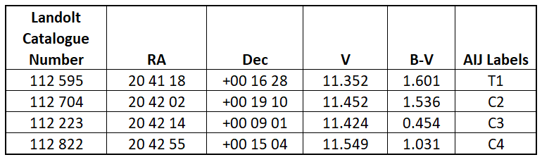
Table 1. Target 11th magnitude Landolt stars.
Non-transformed v magnitudes (differential instrumental magnitudes) we calculated for all six possible pairs of stars (T1 and C2, T1 an C3, T1 and C4, C2 and C3, C2 and C4, C3 and C4). The results are shown in Figure 6 and Table 2. Line profiles of the stars and their FWHMs are shown in Figure 7
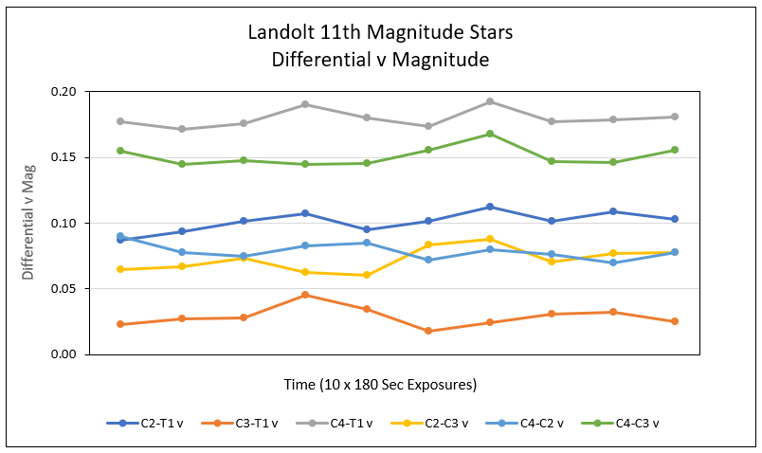
Figure 6. Differential v (instrumental) magnitudes of pairs of 11th magnitude (in V) Landolt stars.
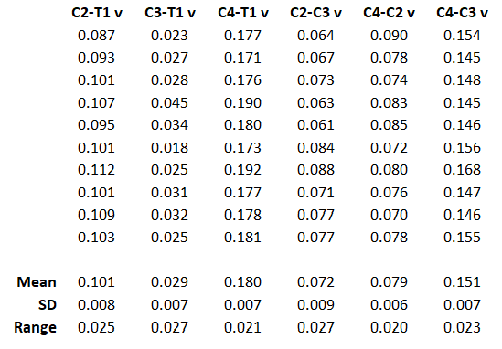
Table 2. Results of differential v magnitude determinations from 10 consecutive images of 11th magnitude Landolt stars.
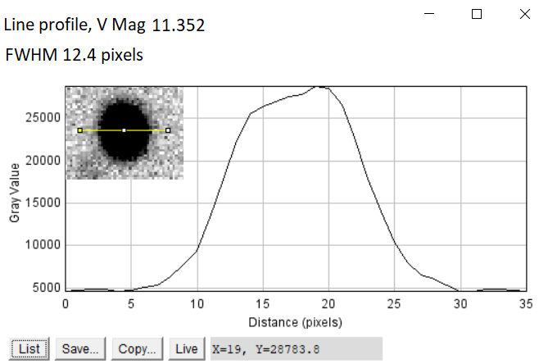 | 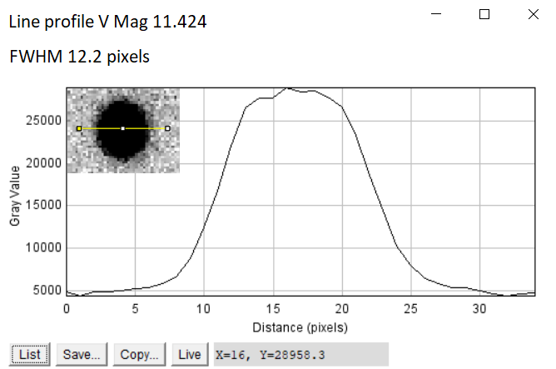
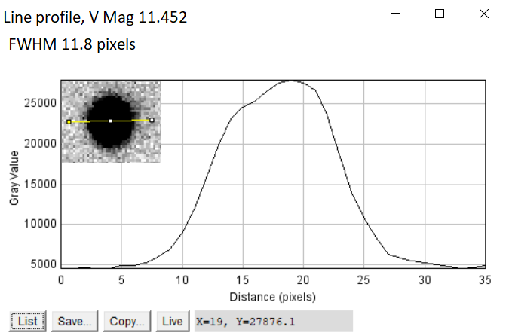 | 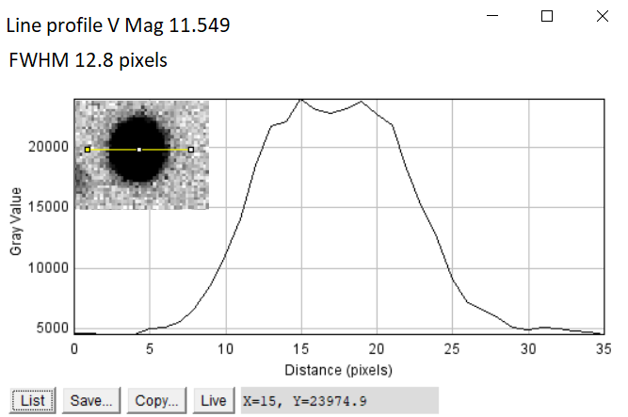
Figure 7. Line profiles and FWHMs of the four 11th magnitude Landolt stars from measurement of on calibrated image in AstroimageJ.
The above results are encouraging. With a 120mm refractor, photometry of 11th magnitude stars is precise enough for time series photometry, although not entirely optimal for the most precise results for that type of observation. For longer period stars, where the results of multiple observations during one night can be averaged, very good results can be expected.
Photometric precision, 10th magnitude Tycho stars
Ten consecutive unbinned images, each exposed at unity gain for 180 seconds through a 120mm refractor at f/7.5 and a Johnson V filter, were taken of a field in which there were four 10th magnitude Tycho stars. Two sets of such exposures were taken, slightly defocussed and moderately defocussed, to assess if the degree of defocus was critical to achieving good photometric precision. The sequence is shown in Table 3.
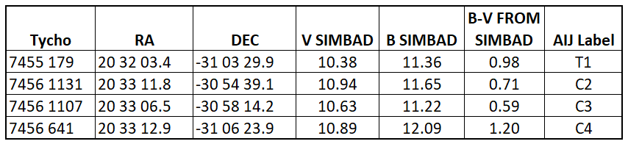
Table 3. 10th magnitude Tycho stars studied.
Differential v magnitudes were calculated for all possible pairs of stars (AstroimageJ labels T1 and C2, T1 and C3, T1 and C4, C2 and C3, C2 and C4, C3 and C4). The results are shown in Figures 8 and 9 for slightly defocussed and moderately defocussed images respectively. Zoomed in views of the degree of defocus are shown in Figure 10 with the centre if this field being RA 20:32:44 DEC -31:03:45. The statistics on the results are shown in Tables 4 and 5.
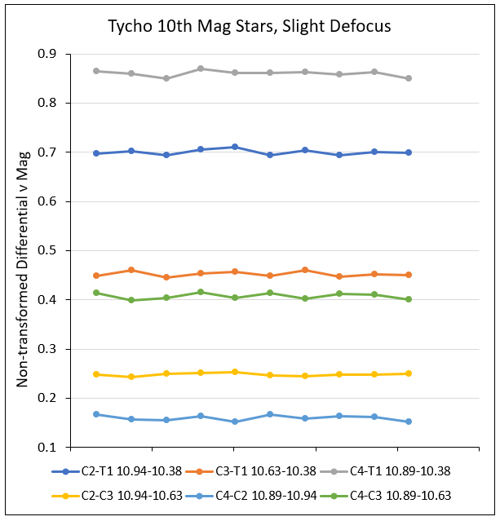
Figure 8. Differential v (instrumental) magnitudes of pairs of slightly defocussed 10th magnitude Tycho stars from 10 consecutive 180 sec exposures at unity gain.
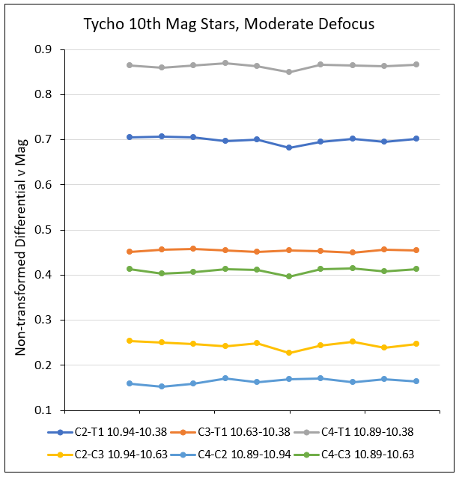
Figure 9. Differential v (instrumental) magnitudes of pairs of moderately defocussed 10th magnitude Tycho stars from 10 consecutive 180 sec exposures at unity gain.

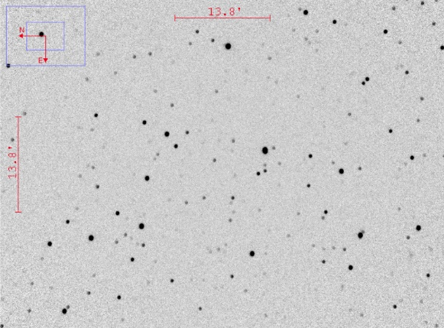 | 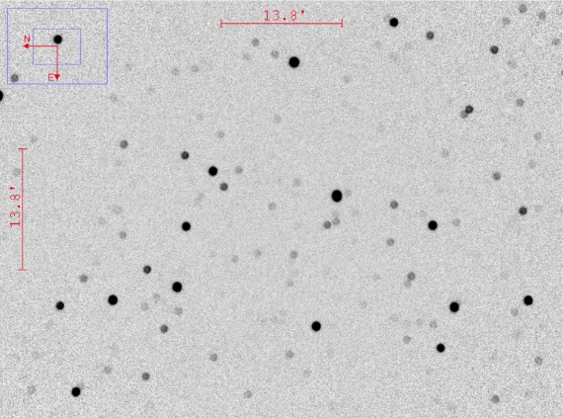
Figure 10. Zoomed in view of the centre of the field containing four 10th magnitude Tycho stars. The left image is slightly defocussed and the right moderately defocussed. The centre of the field is RA 20:32:44 DEC -31:03:45.
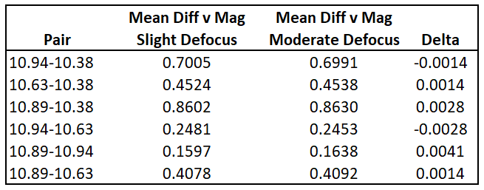
Table 4. Means of the differential v magnitudes of pairs of 10th magnitude Tycho stars. Differences between the magnitude determinations from slightly and moderately defocussed images are at the millimagnitude level.
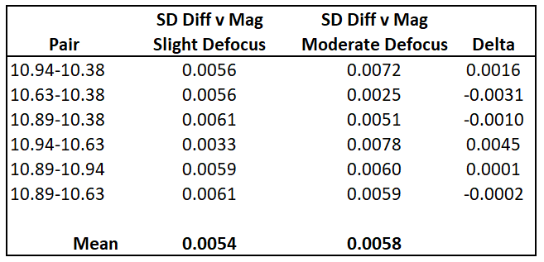
Table 5. Standard deviations of the differential v magnitudes of pairs of 10th magnitude Tycho stars. There would appear to be no significant differences between the slightly and moderately defocussed images.
The statistics are averaged results from measurements of the 10 slightly defocussed images and the 10 moderately defocussed images. The results indicate that good (or even very good) precision for time series photometry can be achieved with a 120mm refractor at f/7.5 for 10th magnitude stars. The means of the differential v magnitudes differ between slight and moderate defocussing at the millimagnitude level, and the standard deviations at a similar level or better. The conclusion is that good precision is not very sensitive to the degree of defocussing. In other words, if the conditions are such that good precision is achieved (whatever settings for gain, exposure and degree of defocus are used), slightly more or slightly less defocus is not likely to affect the photometric precision, provided that the sensor does not saturate in more tightly focussed images.
Photometric precision, 8th magnitude delta Scuti star (RS Gru) and check star
The field was imaged across two consecutive nights through an 80mm f/7.5 refractor. Unbinned exposures of 150 seconds were taken at unity gain, and darks and flats were taken for calibration. Comparison and check stars were HD 206442 and HD 206584 respectively. Light curves of non-transformed V magnitudes were plotted. Note that the variable, comparison and check stars are all 8th magnitude. A typical image, with the variable, comparison and check stars labelled is seen in Figure 11. The line profile of RS Gru from a peak of the light curve on the second observing night is shown in Figure 12. The light curves of the variable and check star for the two nights are shown in Figure 13. It is apparent from the latter figure that the precision is very good.
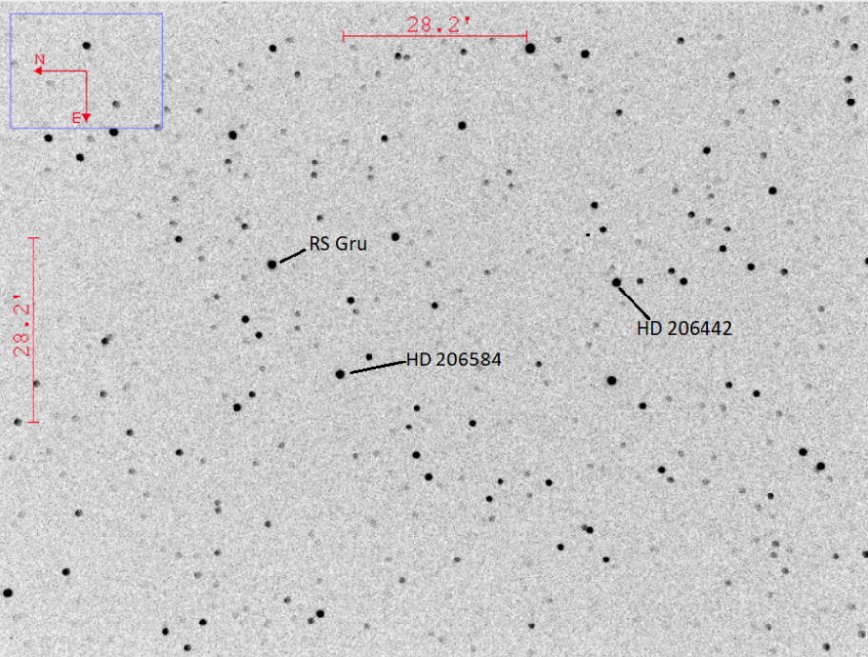
Figure 11. The field of RS Gru. It is clear that the image is substantially defocussed. The comparison and check stars are HD 206442 and HD 206584 respectively.
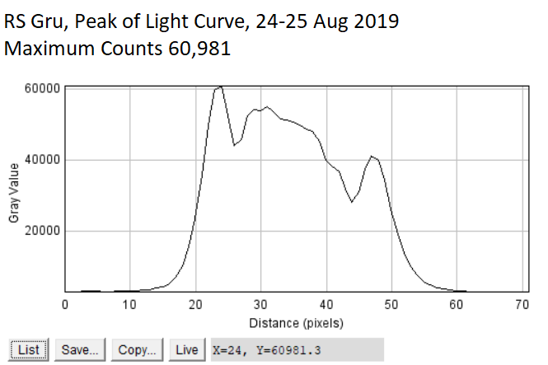
Figure 12. Line profile of RS Gru from a peak of the light curve on the second observing night. The peak value of the counts per pixel is in the upper part of the linear range of the response of the sensor. The substantial degree of defocus is evident.

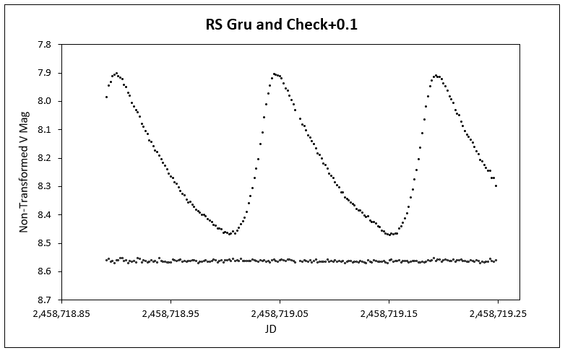
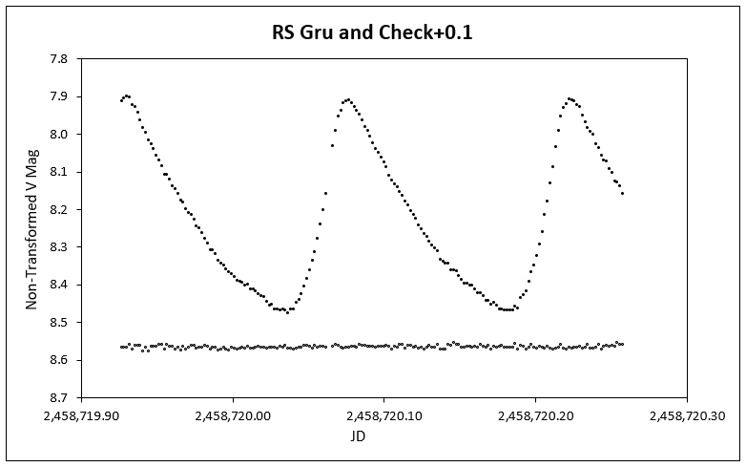
Figure 13. Light curves from two consecutive nights of non-transformed V magnitudes of the delta Scuti star RS Gru and check star, both 8th magnitude.

Photometry of bright stars using gain settings >1e/ADU
The need to adjust the gain setting from 1e/ADU to >1e/ADU and up to 5e/ADU (the maximum possible with this camera) became apparent during a study of the 6th magnitude variable star FR Cet. The reason for targeting this star is that it resides in Category 7, “Other symbols” of the General Catalogue of Variable Stars (GCVS). It is one of 93 stars given the symbol *. These are “Unique variable stars outside the range of the classifications de-scribed above”, i.e., in the rest of the GCVS.
Images were taken with a 120mm refractor at f/7.5. Initially, the camera was set to unity gain (1 e/ADU), and 15 second exposures. Precision was poor with these settings. On the next observing night, the exposure was lengthened to 45 seconds, and the gain adjusted to 2.75 e/ADU. On the third and subsequent observing nights, the exposure was further lengthened to 120 seconds and the gain set to 5 e/ADU.
In the following, the calculated differential V magnitude of only the check star is reported, for the three exposures and gain settings described above.
Figure 12 shows the important stars in the field of FR Cet from the planetarium programme Guide. The mag 72 star, which would appear at first sight to be the best comparison star, is a spectroscopic binary and is also variable (from personal study) although its variability does not appear to be recorded in the literature. Therefore, the 82 and 88 magnitude stars were used as comparison and check stars respectively.
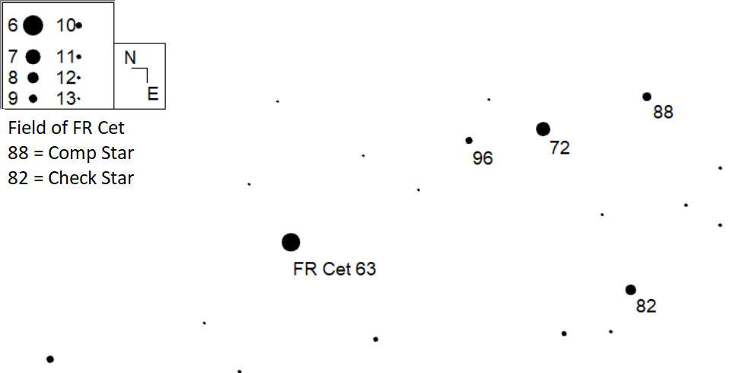
Figure 12. The field of FR Cet from Guide. The stars labelled 82 and 88 were used as comparison and check stars respectively. The star labelled 72 is a spectroscopic binary and is variable.

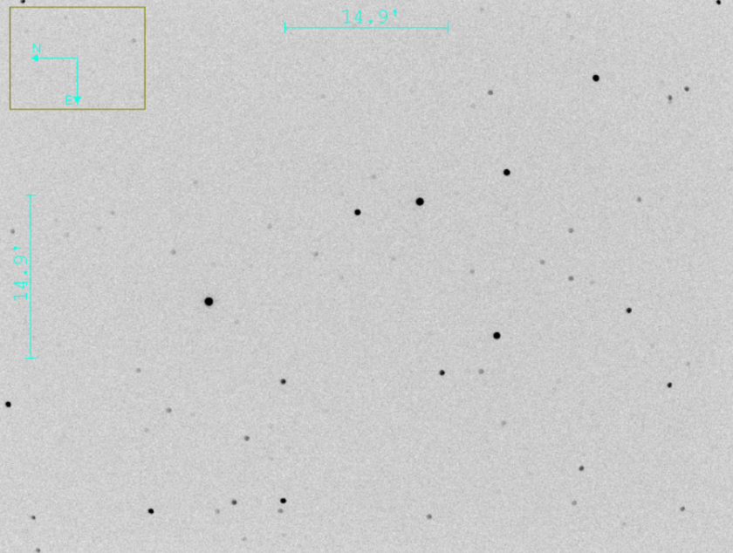
Figure 13. Field of view of FR Cet taken with the ZWO camera through an 120mm f/7.5 refractor. Orientation is the same as that of Figure 12, and the scale is similar.

With brighter stars, the gain needs to be adjusted to be less than 139 dB units (>1 e/ADU) to allow long enough exposures to optimize the precision.
The bottom line is that the best precision is achieved when:
Variable and comparison stars are of similar magnitude
The brightness of the target stars is appropriate for the aperture of the imaging telescope (for the ZWO camera under study, that means 8th magnitude or brighter stars for an 80mm refractor, and 10th magnitude or brighter stars for a 120mm refractor).
The degree of defocus, exposure, and gain setting are tuned so that the peak count per pixel for the brightest star is close to but below the top of the range of the linear response of the sensor.
BV transformation coefficients
These were determined using E Region standard stars on two occasions, 21 August 2019 and 2 February 2020. The camera was set to unity gain for both. In 2019 unbinned images of 7th and 8th magnitude stars were taken through an 80mm refractor at f/7.5. In 2020 images binned 2x2 of 8th and 9th magnitude stars were taken through an 120mm refractor at f/7.5. The plots are shown in Figure 14.
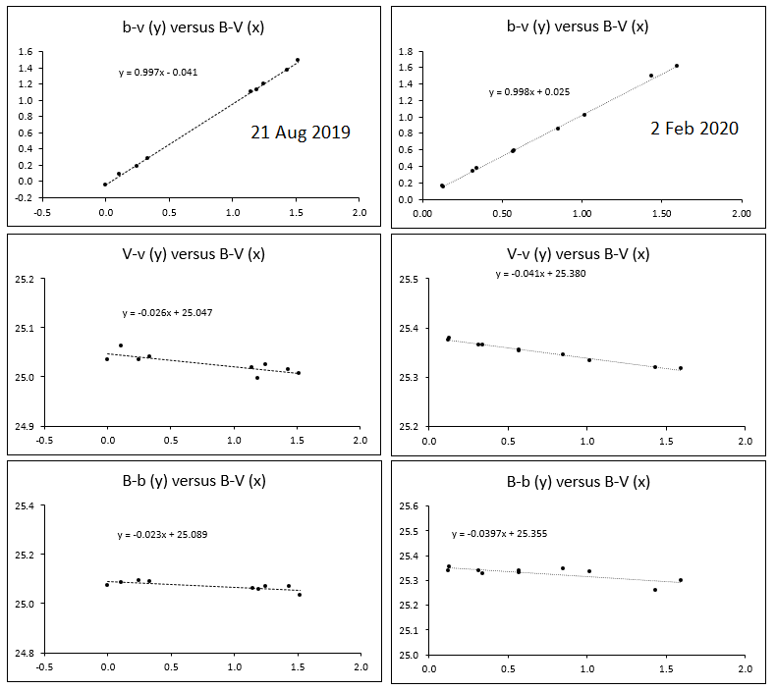
Figure 14. Plots for BV transformation coefficients. The left panel represents data from 21 August 2019 and the right panel data from 2 February 2020. The 2019 images were taken through an 80mm refractor and the 2020 images through a 120mm refractor
The transformation coefficients from the slopes of the above plots are listed in Table 6. The August 2019 coefficients were never put to use for calculating transformed BV magnitudes because observations between then and Decemeber 2019 concentrated on the precision of the ZWO camera, and non-transformed V magnitude time series observations of variable stars. Smoke haze and/or cloud prevented any serious observing until early February 2020.
Transform | August 2019  Coefficients | February 2020  Coefficients
b-v/B-V | 1.003 | 1.002
V-v/B-V | -0.026 | -0.041
B-b/B-V | -0.023 | -0.040
Table 6. BV transformation coefficients from 21 August 2019 and 2 February 2020.

Photometric accuracy: transformed BV photometry of 8th magnitude standard stars
A photometric accuracy trial for B and V transformed magnitudes was performed on 2 February 2020. Transformation coefficients determined on the same night were employed. The targets were 8th magnitude standard stars from the E Regions, imaged in three fields. The stars are listed in Table 6 and the results are shown in Table 7. It should be noted that each result is from the measurement of one image (i.e.), the results are not averages of multiple measurements.
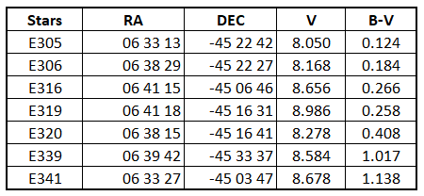
Table 6. E Region standards used for testing photometric accuracy of the ZWO ASI1600MM camera.

 | b-v/B-V Transform | B-b/B-V  Transform |  | V-v/B-V  Transform
Pair  (“Var” Comp) | ΔB-V | ΔB | ΔV | ΔB | ΔV
E305 E341 | 0.035 | 0.021 | -0.014 | -0.018 | -0.053
E339 E306 | -0.035 | -0.040 | -0.005 | -0.008 | 0.027
E339 E320 | -0.029 | -0.030 | -0.001 | -0.007 | 0.022
E306 E320 | 0.006 | 0.010 | 0.004 | -0.002 | -0.004
E319 E316 | 0.001 | -0.008 | -0.009 | -0.008 | -0.009
Table 7. Results of accuracy trial, using images of the fields containing the E Region standards listed in Table 6. Delta (Δ) means calculated value minus catalog value.

The results in Table 7 are encouraging. When the B-b/B-V transform is used to determine V, four of the five values differ from the catalog value by less than 0.01 magnitude. When the V-v/B-V transform is used to determine B, again the differences from catalog for four results are less than 0.01 magnitude. The pair for which the differences are greater than 0.01 magnitude (E305 E341) have the greatest difference in B-V colour indices (0.124 to 1.138).
For those not familiar with the calculation of transformed magnitudes the following is relevant to the previous paragraph. The B-V colour index of a variable star is calculated from the b-v/B-V transform. If the B-b/B-V transform is then employed, the B magnitude of the variable is calculated, and the V magnitude is derived from B - (B-V). If the V-v/B-V transform is employed, the V magnitude is calculated, and the B magnitude is derived from V + (B-V). Analagous calculations apply to other transforms and magnitudes (e.g., V and I).

End of Document

