ZWO ASI1600MM-COOL Linearity and Precision Testing
Roy Axelsen (ARX), Brisbane, Australia
10 October 2019

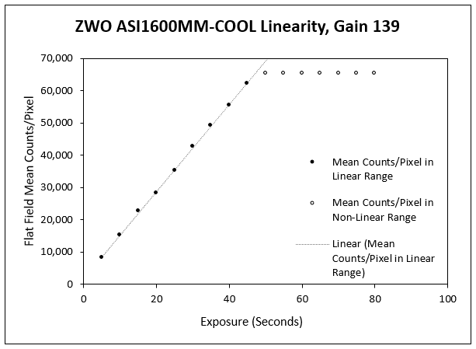
Figure 1. Linearity plot with the gain set at 139 dB units (1e-/ADU, unity gain). The data plateaus at 65,504 counts. The highest data point in the linear range is 62,132 counts/pixel, as listed in Table 1 below.

Exposure in Seconds | Mean Counts/Pixel in Linear Range, Unity Gain | Predicted Mean Counts/Pixel in Linear Range, Unity Gain | Residuals
5 | 8,196 | 8494 | -298
10 | 15,158 | 15240 | -83
15 | 22,739 | 21987 | 752
20 | 28,308 | 28734 | -426
25 | 35,268 | 35481 | -213
30 | 42,656 | 42228 | 428
35 | 49,127 | 48974 | 153
40 | 55,564 | 55721 | -158
45 | 62,312 | 62468 | -156

Table 1. Regression analysis of mean counts per pixel in linear range, unity gain. The data in the first two columns correspond to the part of the plot in the linear range in Fig. 3

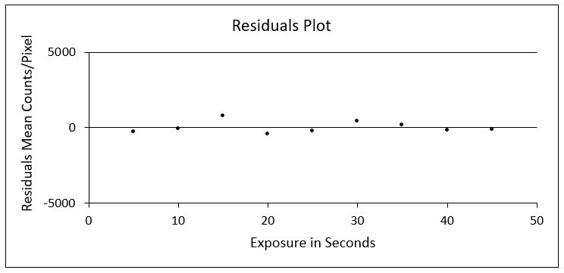
Figure 2. Residuals plot, from the data in columns 1 and 4 of Table 1.

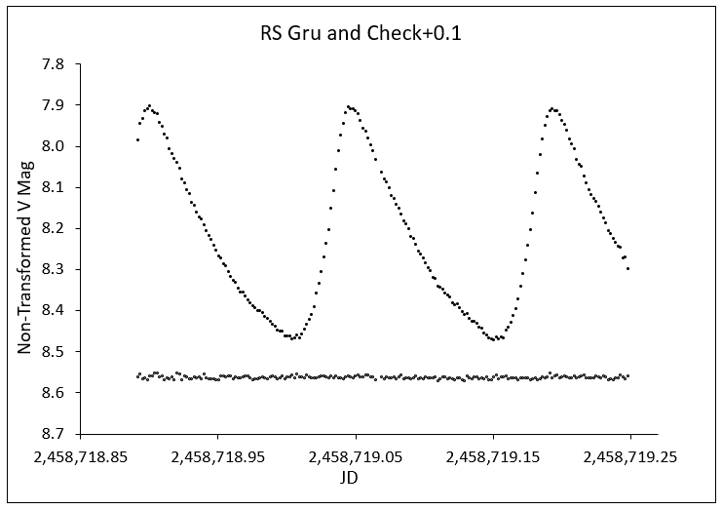
Figure 3. Light curve of RS Gru and check star (+0.1 Mag) for the night of 23-24 August 2019. Each data point is from one exposure. Autoguided exposures were 150 seconds, taken through an 80mm f/7.5 refractor. Camera set at unity gain. Comparison star HD 206442, V and B-V taken to be 8.485 and 0.490 respectively; check star HD 206584, V and B-V taken to be 8.451 and 0.950 respectively.

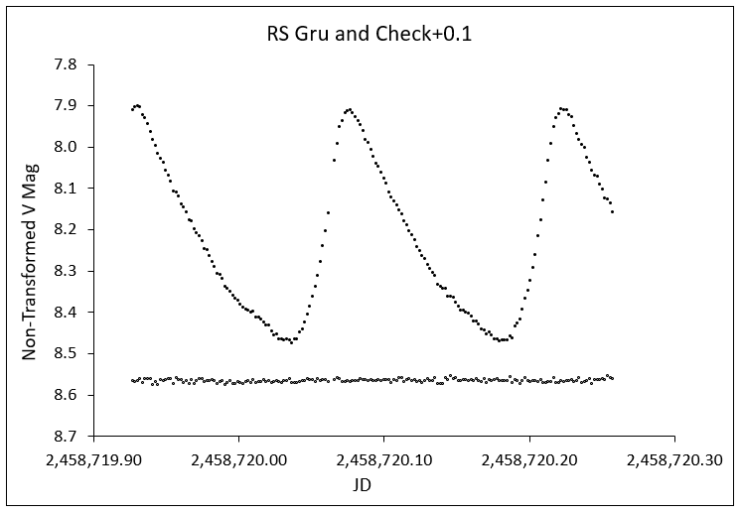
Figure 4. Light curve of RS Gru and check star for the night of 24-25 August 2019. Same equipment, exposures and camera gain setting as for Figure 3.

 | 23-24 August 2019 |  | 24-25 August 2019
 | Before Meridian Flip | After Meridian Flip | Before Meridian Flip | After Meridian Flip
 | 8.4669 | 8.4637 | 8.4668 | 8.4644
 | 8.4615 | 8.4677 | 8.4628 | 8.4606
 | 8.4586 | 8.4630 | 8.4635 | 8.4628
 | 8.4628 | 8.4655 | 8.4648 | 8.4686
 | 8.4643 | 8.4660 | 8.4697 | 8.4705
 | 8.4591 | 8.4629 | 8.4622 | 8.4670
 | 8.4597 | 8.4688 | 8.4672 | 8.4684
 | 8.4629 | 8.4639 | 8.4641 | 8.4664
 | 8.4638 | 8.4592 | 8.4645 | 8.4659
 | 8.4706 | 8.4688 | 8.4689 | 8.4667
Mean | 8.4630 | 8.4649 | 8.4654 | 8.4661
Difference Between Means | 0.0019 |  | 0.0007
SD | 0.0037 | 0.0030 | 0.0026 | 0.0029
Range | 0.0120 | 0.0096 | 0.0075 | 0.0099

Table 2. Precision of RS Gru check star photometry. Ten consecutive measurements of the non-transformed V magnitude of the check star were taken before and after the meridian flip on each of two nights. Difference Between Means = (Mean after meridian flip) minus (Mean before meridian flip).

JD UTC | (Star 1)v - (Star 3)v | (Star 3)v - (Star 4)v | (Star 2)v - (Star 4)v + 0.2 | (Star 4)v - (Star 1)v - 0.3
2458749.012 | 0.447 | 0.415 | 0.359 | 0.562
2458749.014 | 0.453 | 0.413 | 0.362 | 0.567
2458749.016 | 0.447 | 0.411 | 0.356 | 0.558
2458749.018 | 0.448 | 0.415 | 0.362 | 0.563
2458749.020 | 0.442 | 0.414 | 0.353 | 0.557
2458749.022 | 0.444 | 0.413 | 0.357 | 0.558
2458749.024 | 0.447 | 0.416 | 0.362 | 0.563
2458749.026 | 0.448 | 0.410 | 0.358 | 0.558
2458749.029 | 0.450 | 0.406 | 0.357 | 0.556
2458749.031 | 0.446 | 0.413 | 0.353 | 0.559
SD | 0.003 | 0.003 | 0.003 | 0.003
Range | 0.011 | 0.010 | 0.010 | 0.011

Table 3. Ten consecutive differential v magnitude measurements of each of four pairs of 10th magnitude Tycho-2 stars. v = Instrumental magnitude through Johnson V filter. Star 1 = TYC 7455 179; Star 2 = TYC 7456 1131; Star 3 = TYC 7456 1107; Star 4 = TYC 7456 641. Data on these stars is listed in Table 4. Autoguided exposures of 180 seconds for aperture photometry were taken through a 120mm f/7.5 refractor.

Data from Guide9
Star | V | V Err | B-V | B-V Err
TYC 7455 179 | 10.386 | 0.057 | 0.963 | 0.079
TYC 7456 1131 | 10.946 | 0.098 | 0.698 | 0.115
TYC 7456 1107 | 10.635 | 0.071 | 0.588 | 0.081
TYC 7456 641 | 10.893 | 0.117 | 1.192 | 0.217
Table 4. Data on 10th magnitude Tycho-2 stars observed for precision testing. These values are very close to those in SIMBAD.

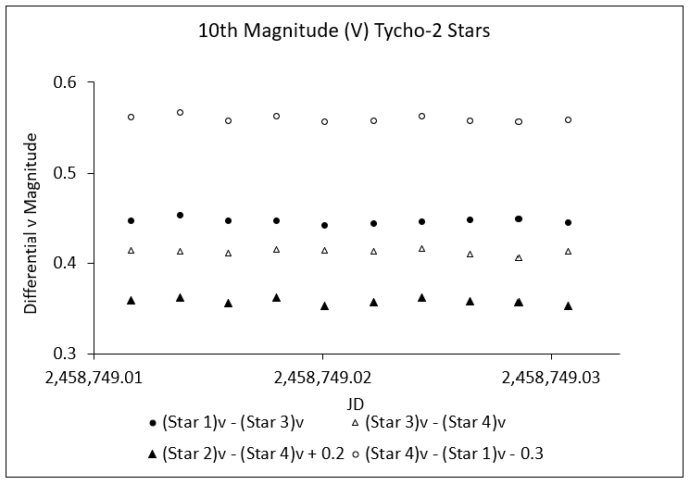

Figure 5. Graphical display of the data on 10th magnitude Tycho-2 stars from Table 5. The plotted values are differential instrumental magnitudes of observations through a Johnson V filter, adjusted where necessary (see legend at the bottom of the plot) to scale of the y axis for all data to be seen optimally.

 | Star | V | B-V
Star 1 | 112 595 | 11.352 | 1.601
Star 2 | 112 704 | 11.452 | 1.536
Star 3 | 112 223 | 11.424 | 0.454
Star 4 | 112 822 | 11.549 | 1.031
Table 5. Data on the 11th magnitude (V) Landolt stars observed for precision testing. See Table 6 below.

JD UTC | (Star 2)v - (Star 1)v | (Star 2)v - (Star 3)v - 0.05 | (Star 4)v - (Star 3) v | (Star 4)v - (Star 1)v + 0.05
2458754.890 | 0.087 | 0.014 | 0.154 | 0.227
2458754.892 | 0.093 | 0.017 | 0.145 | 0.221
2458754.894 | 0.101 | 0.023 | 0.148 | 0.226
2458754.896 | 0.107 | 0.013 | 0.145 | 0.240
2458754.899 | 0.095 | 0.011 | 0.146 | 0.230
2458754.901 | 0.101 | 0.034 | 0.156 | 0.223
2458754.903 | 0.112 | 0.038 | 0.168 | 0.242
2458754.905 | 0.101 | 0.021 | 0.147 | 0.227
2458754.907 | 0.109 | 0.027 | 0.146 | 0.228
2458754.909 | 0.103 | 0.027 | 0.155 | 0.231
SD | 0.008 | 0.009 | 0.007 | 0.007
Range | 0.025 | 0.027 | 0.023 | 0.021

Table 6. Ten consecutive differential v magnitude measurements of each of four pairs of 11th magnitude Landolt standards stars (Landolt 1992). v = Instrumental magnitude through Johnson V filter. Equipment, exposures and settings were as for the 10th mag Tycho-2 stars.

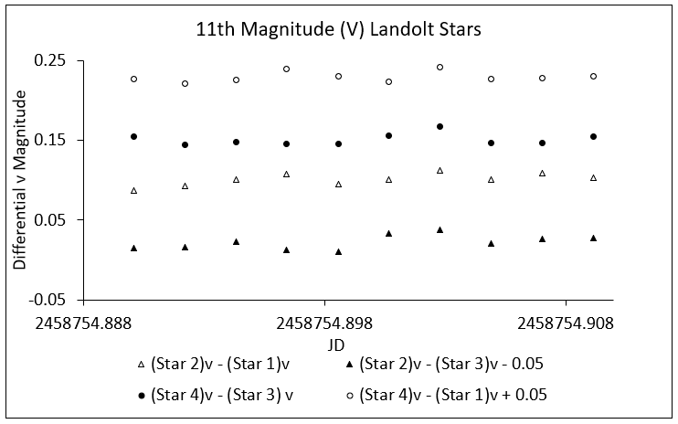
Figure 6. Graphical display of the data on 11th magnitude Landolt stars from Table 6. The plotted values are differential instrumental magnitudes of observations through a Johnson V filter, adjusted where necessary (see legend at the bottom of the plot) to scale the y axis for all data to be seen optimally.

