FY Lib BSM_NM2: Note very small aperture. Default was 1.5X FWHM
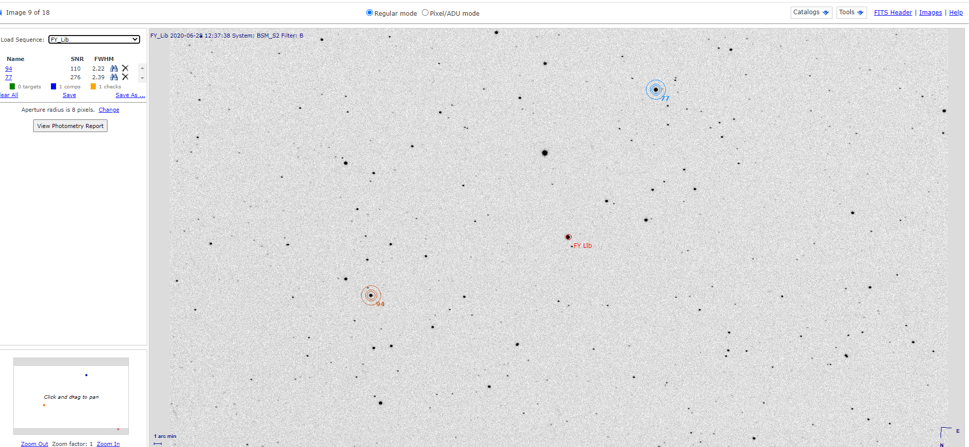
FY Lib: All images in all filters from BSM_S and BSM_S2 appear like this image.

