Quiz 2 illustrations
3a.
3b

4a.
4b
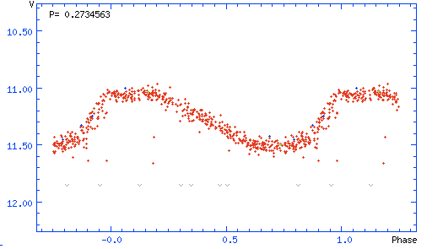
11.
12.

