Title: Instructions for Formatting an Article for JAAVSO
Author One, Author Two, Author Three
Affiliation, Affiliation Street Address, City, State, Postcode, Country; email@host.affiliation
Author Four, Author Five
Affiliation2, Affiliation Street Address2, City, State, Postcode, Country; email@host.affiliation2
Submitted February 15, 2015

Subject Keywords
AAVSO International Database; Photometry, CCD; Cataclysmic Variables; stars: individual (AM Her, TT Ari)

Abstract
The abstract should be concise and one paragraph. It should be as informative as possible; it should give details of the article, including the conclusions arrived at. Avoid writing a merely descriptive abstract that only tells what the article is about. In other words, the abstract should be a short summary of the article in which you may state the question at issue, the purpose of the study, the procedures followed, and your results, conclusions, or recommendations. References should not be given in the abstract.

1. Introduction
The author's responsibility is to provide a carefully prepared manuscript that generally conforms to JAAVSO style. The JAAVSO format changed significantly in 2014, so use JAAVSO issues beginning with Volume 43, Number 1, as your guide. Articles accepted for this issue may be seen here.

2. Body of the manuscript

The body of the paper consists of numbered sections that present the main findings. These sections should be organized to best present the material.

It is often important to refer back (or forward) to specific sections. Such references are made by indicating the section number, for example, “In Sec. 2 we showed…” or “Section 2.1 contained a description….” If the word Section, Reference, Equation, or Figure starts a sentence, it is spelled out. When occurring in the middle of a sentence, these words are abbreviated Sec., Ref., Eq., and Fig. At the first occurrence of an acronym, spell it out followed by the acronym in parentheses, e.g., charge-coupled device (CCD).

2.1 Methods

This section describes the methodology used for relevant data acquisition. Figures, finding charts, tables, and equations could be presented here, as shown in the following examples.

Table 1. Comparison stars.
Identification* R.A. (2000) Dec. (2000) B V B-V
h m s º ' "
GSC 1948-1556 08 40 05.47 +27 39 12.1 12.526 11.998 0.528
GSC 1948-1451 08 40 09.30 +27 41 19.4 13.627 12.946 0.681
GSC 1948-1631 08 40 34.19 +27 47.50.0 13.972 13.204 0.768
*Table footnotes are placed directly following the table and are indicated with superscripted symbols, letters, or numerals.

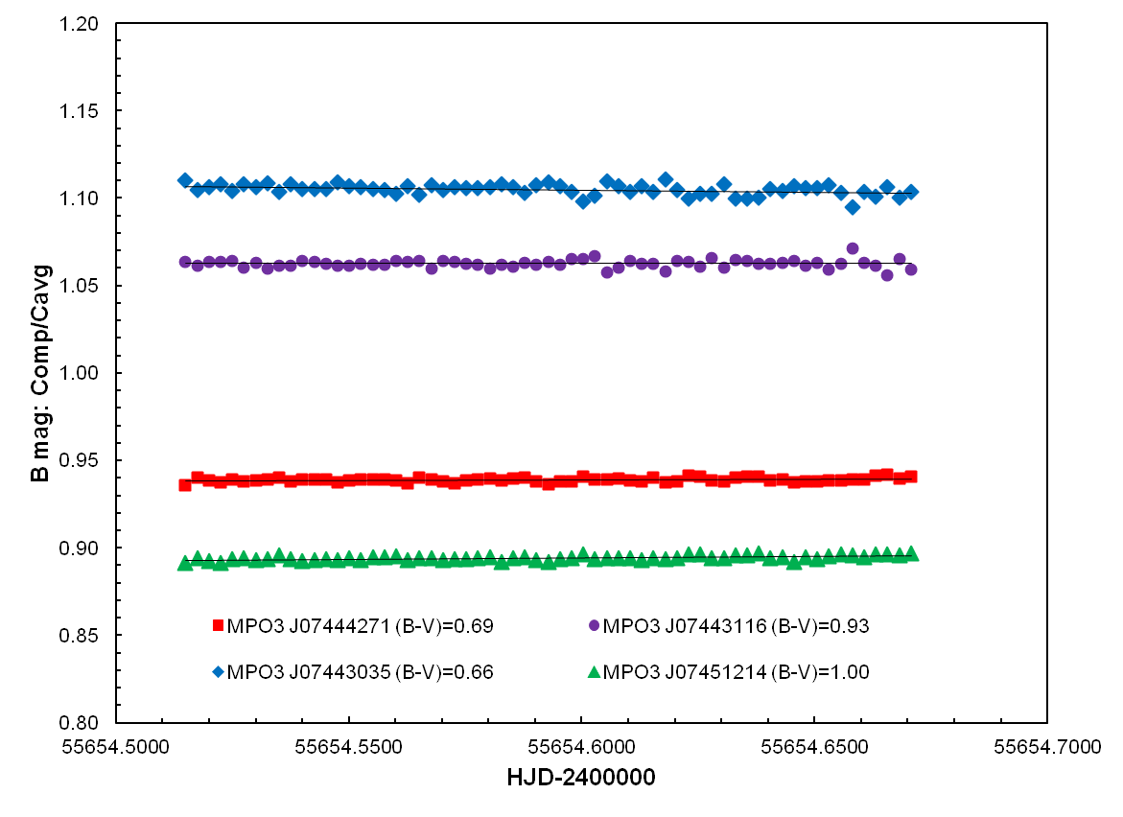
Figure 1. This is the figure caption for figure 1. Representative plot showing behavior of comparison stars (B mag: Comp/Cavg) used for TYC 790-1124-01 during a session when the air mass ranged from 1.134 to 1.996

2. 2. Results

This section should present the scientific outcome of the work. It should present the data, data analysis techniques, modeling and period searches (if any), comparison with data from literature and data interpretation. Figures and tables (also see section 3) should be presented to support the discussion.

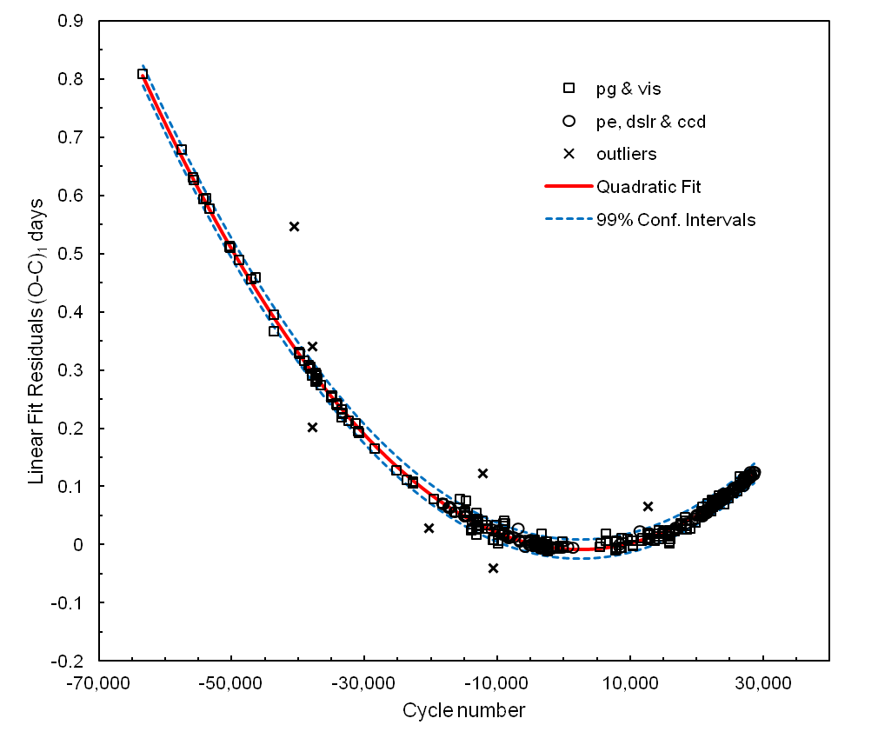
Figure 2. This is the figure caption for figure 2. Plot of published time-of-maximum data vs epoch using linear elements from Samus (2012). Parabolic relation of O-C residuals is well fit by quadratic expression.

(1)
(Use TAB to insert equation, centered; TAB again to insert equation number)

3. Conclusions

This section presents the conclusions of the manuscript. For research papers, this should outline the main results of the paper and perhaps future directions of research that can be followed. Figures, finding charts, tables and equations in support to the discussion could be presented here, as shown in the following examples.

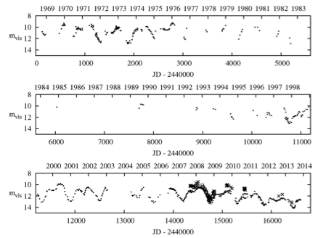
Figure 3. This is the figure caption for figure 3. AAVSO light curve for CT Lac, 1968 to mid-2014: filled circles, visual data; open squares, tri-color green data; crosses, V-band data. The star has been well-observed visually for the past 15 years. This period has been characterized by a fading of the star’s mean brightness by about two magnitudes.

Table 2. Observers of CT Lac through 2014 August 1.

Observer (AAVSO Obs. code) Obs. band Min(MJD) Max(MJD) No. of Obs.

Maurer (MPR) Visual 50685 56871 281
Kriebel (KWO) Visual 53939 56870 194
Lowder (LX) Visual 40134 46029 164
Morelle (MEV) Tricolor G 54420 54841 47
O’Connor (OCN) Visual 43467 51044 41
Bortle (BRJ) Visual 41643 42167 14
Sharpe (SHS) Visual 54413 54765 5
Holmberg (HGUA) Johnson V 56151 56420 4
Ford (FD) Visual 40820 40951 2

Acknowledgements
This section (not numbered) is used to identify people who have aided the authors in accomplishing the work presented and to acknowledge sources of funding. AID data should be acknowledged as follows:
“We acknowledge with thanks the variable star observations from the AAVSO International Database contributed by observers worldwide and used in this research.”

References
AAVSO. 2013, observations from the AAVSO International Database (http://www.aavso.org).
Agerer, F., and Hübscher, J. 1997, Inf. Bull. Var. Stars, No. 4472, 1.
Ahnert, P. 1959b, Mitt. Veränderliche Sterne, No. 419, 1.
Ashbrook, J. 1949, Astron. J., 54, 198.
Aubaud, J. 1992, AFOEV Bull., 59, 3.
Balázs, J., and Detre, L. 1949, Commun. Konkoly Obs., No. 21, 1.
Berdnikov, L. N. 1977, Perem. Zvezdy Prilozh., 3, 329.
Berry, R., and Burnell, J. 2005, Handbook of Astronomical Image Processing, Willmann-Bell, Richmond.
Braune, W., and Mundry, E. 1973, Astron. Nachr., 294, 225.
Buchheim, B. 2006, in The Society for Astronomical Sciences 25th Annual Symposium on Telescope Science. Held May 23-25, 2006, at Big Bear, CA, Society for Astronomical Sciences, Rancho Cucamonga, CA, 183.

Appendix

An appendix could be used for additional material, derivations or information that is not included anywhere else in the manuscript.
Magnitudes should conform to relatively well known systems such as Johnson-Cousins, Sloan, etc. Authors introducing a new passband should read the IAU Resolution regarding magnitude systems and follow the guidelines given there.

